MedML Documentation
Setup:
- Click the green “Code” dropdown in the Github repo
-Select to download zip
- Alternatively clone through the https link option and insert this into the “Clone from repo” option most IDEs have, and then click to view/ “Open” project. Then you do not need to do step 2.
2) Unzip the download -> open the download in an IDE that can run Python (e.g. like Pycharm)
3)You should see something like this now:
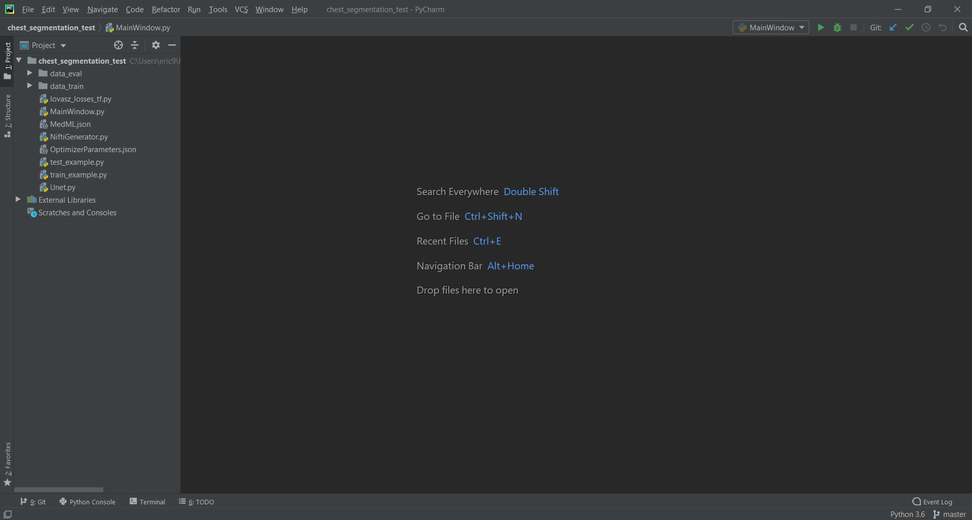

Getting Started:
From the side pane you should see the application folder and within it your data_train and data_eval data folders. Be sure that your data folders have these names
The main programs of interest here are MainWindow.py, test_example.py, and train_example.py
-MainWindow.py is the GUI from which you will input specifications to run training. (creates JSON files MedML.json and if the “Set Optimizer Parameters” pane is used OptimizerParameters.json as well, otherwise OptimizerParameters.json will be created from running train_example.py)
-train_example.py is what you should run to perform training after you have set and submitted parameters in MainWindow.py GUI
-test_example.py is what you run after successfully completing training through train_example.py script. This will evaluate the model.

MainWindow.py:
To get the GUI up, right click MainWindow.py and select to “Run MainWindow.py”. You should now see the GUI:
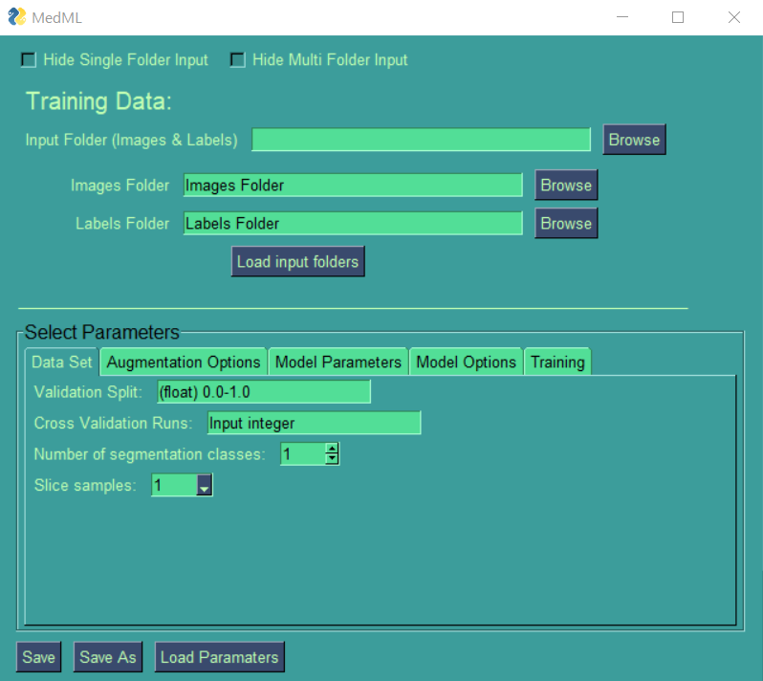
Parameters
Data Set:
Validation Split: a parameter that specifies how big chunk of training data will be used for validation. It is a float value between 0 and 1. Validation data is not used for training, but to evaluate the loss and the accuracy. For example: Validation Split = 0.3 will cause that 30% of the training data will be used for validation.
Augmentation: can be used to artificially expand the size of a training dataset by creating modified versions of images in the dataset. Training deep learning neural network models on more data can result in more skillful models, and the augmentation techniques can create variations of the images that can improve the ability of the fit models to generalize what they have learned to new images. Keras deep learning neural network library provides the capability to fit models using image data augmentation via the ImageDataGenerator class.
Cross Validation Runs: are runs to evaluate ML models by training several ML models on subsets of the available input data and evaluating them on the complementary subset of the data. It is used to detect overfitting, i.e., failing to generalize a pattern.
Number of Segmentation Classes: Suppose you want to know where an object is in the image, the shape of that object, which pixel belongs to which object. In this case you want to segment the image, i.e., each pixel of the image is given a label. The goal of segmentation is to train a neural network to output a pixel-wise mask of the image. This helps in understanding the image at a much lower level, i.e., the pixel level.
Slice samples: is how much each chunk/slices of samples in your data set you want to analyze at a time. Values: 1, 3, 5, 7, 9
Model Parameters:
UNet Type: The UNet is convolutional network architecture for fast and precise segmentation of images. It can localize and distinguish borders by doing classification on every pixel, so the input and output share the same size. For an example, for an input image of size 2x2: [[255, 230], [128, 12]] with each number being a pixel, the output will have the same size of 2x2: [[1,0], [1, 1]]. Dimension options: 2D, 2.5D, 3D
X, Y: x and y are the values of the dimensions for the model
Starting filters: Filters enhance the clarity of the signal that is used for machine learning. This value is used for determining the number of kernels to convolve with the input volume. Each of these operations produce a 2D activation map. Recommended starting with filters in the range of [32, 64, 128] in the earlier and increasing up to [256, 512, 1024] in the deeper layers. Default value: 32. Start with a smaller number of filters and only increase when necessary. This you control with the filter increasing rate (Default value: (float) 1.0-5.0).
Depth: How deep the network is. Depth is used for visual recognition and it translates to the 3rd dimension of an image. E.g. you have an image, and the size of this input is 32x32x3 which is (width, height, depth).
Model Options:
Activation Function: activation function of a given node defines the output of that node given an input or set of inputs.
- Relu: rectified linear activation function or ReLU, is a piecewise linear function that will output the input directly if it is positive, otherwise, it will output zero. Max (0, z)
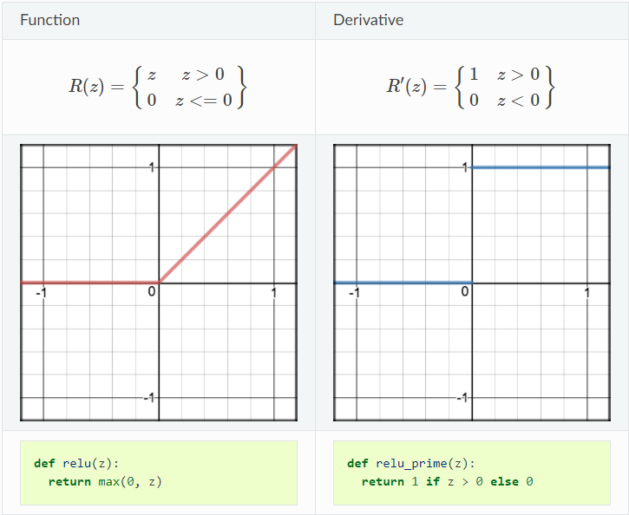
- Leaky Relu: variant of ReLU. Instead of being 0 when z < 0, a leaky ReLU allows a small non-zero, constant gradient αα (Normally, α=0.01α=0.01). However, the consistency of the consistency of the benefit across tasks is presently unclear. Leaky ReLUs are one attempt to fix the “dying ReLU” problem by having a small negative slope (of 0.01, or so).
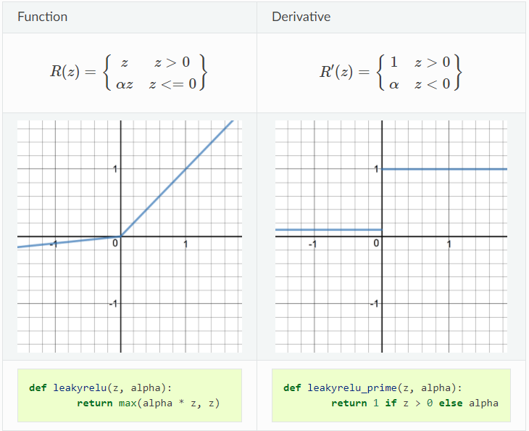
- Sigmoid: takes a real value as input and outputs another value between 0 and 1. It’s easy to work with and has all the nice properties of activation functions: it’s non-linear, continuously differentiable, monotonic, and has a fixed output range.
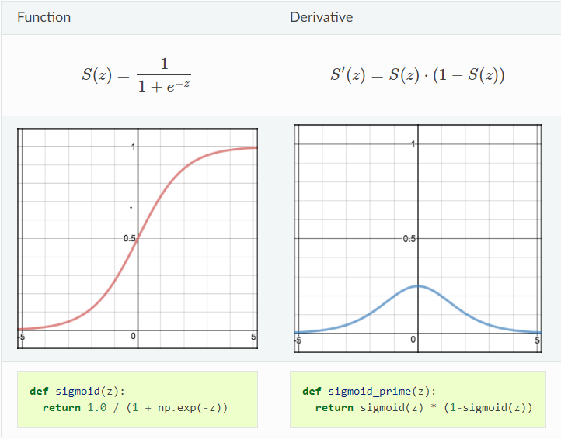
Dropout Rate: the probability of training a given node in a layer, where 1.0 means no dropout, and 0.0 means no outputs from the layer. Values: On: 0.5, Off: 0
Batch Normalization: is a technique for training very deep neural networks that standardizes the inputs to a layer for each mini batch. This has the effect of stabilizing the learning process and dramatically reducing the number of training epochs required to train deep networks.
Max pool: is used to reduce the spatial dimensions of the output volume, downsampling layer.
Upconv: method of handling a data imbalance in the data you are using. The idea is that the majority data set indicates one behavior and the minority indicates another. Without accounting for this, you end up with bat results. Upsampling is altering the two data sets to give them a more equal “weight”. This is where upsampling layer is controlled.
Residuals: are the differences between observed and predicted values of data. They are a diagnostic measure used when assessing the quality of a model. They are also known as errors.
Multiprocessing: parallelize workflows in the training scripts.
Training:
Epoch: the number of passes of the entire training dataset the machine learning algorithm has completed.
Batch Size: the number of training examples utilized in one iteration.
Optimizer: algorithms or methods used to change the attributes of your neural network such as weights and learning rate to reduce the losses. Optimizers help to get results faster.
- Adam: Adaptive Moment Estimation (Adam) combines the ideas from both RMSProp and Momentum. It computes adaptive learning rates for each parameter. Default values: Beta1 = 0.9, Beta2 = 0.999, Epsilon = 1e-7, Amsgrad = False
- Rectified Adam: Update to Adam to obtain a higher accuracy/more generalizable deep neural network and complete training in fewer epochs. Adaptive learning rate optimizers (such as Adam) both: struggle to generalize during the first few batches updates and had very high variance. Rectified Adam rectifies this by applying warm up with a low initial earning rate and simply turning off the momentum term for the first few sets of input training batches. Default values: Beta1 = 0.9, Beta2 = 0.999, Epsilon = None, Decay = 0., WeightDecay = 0., Amsgrad = False, TotalSteps = 0, Warmuproportion = 0.1, MinLr = 0.
- RMSProp: an adaptive learning rate optimization algorithm, Root Mean Square Prop (RMSProp) works by keeping an exponentially weighted average of the squares of past gradients. RMSProp then divides the learning rate by this average to speed up convergence. Default values: Rho = 0.9, Momentum = 0.0, Epsilon = 1e-07, Centered = False
- Adagrad: (short for adaptive gradient) adaptively sets the learning rate according to a parameter. Parameters that have higher gradients or frequent updates should have slower learning rate so that we do not overshoot the minimum value. Parameters that have low gradients or infrequent updates should have faster learning rate so that they get trained quickly. Default values: InitialAccumVal = 0.1, Epsilon = 1e-7
- SGD: Stochastic Gradient Descent. A few samples are selected randomly instead of the whole data set for each iteration. In Gradient Descent, there is a term called “batch” which denotes the total number of samples from a dataset that is used for calculating the gradient for each iteration. In typical Gradient Descent optimization, like Batch Gradient Descent, the batch is taken to be the whole dataset. Although, using the whole dataset is useful for getting to the minima in a less noisy or less random manner, but the problem arises when our datasets get huge. The problem is solved by Stochastic Gradient Descent. In SGD, it uses only a single sample to perform each iteration. The sample is randomly shuffled and selected for performing the iteration. Default values: Momentum = 0.0, Nesterov = False
- Nadam: (Nesterov-accelerated Adaptive Moment Estimation) combines Adam and NAG. Much like Adam is essentially RMSprop with momentum, Nadam is Adam with Nesterov momentum. Default values: Beta1 = 0.9, Beta2 = 0.999, Epsilon = 1e-7
- Adamax: It is a variant of Adam based on the infinity norm. Adamax is sometimes superior to Adam, specially in models with embeddings. Default values: Beta1 = 0.9, Beta2 = 0.999, Epsilon = 1e-7
Learning rate: a tuning parameter in an optimization algorithm that determines the step size at each iteration while moving toward a minimum of a loss function. Learning rate controls how quickly the model is adapted to the problem. Often is value between 0.0 and 1.0
Loss function: a method of evaluating how well a specific algorithm models the given data. If predictions deviate too much from the actual results, loss function would cough up a very large number. Gradually, with the help of some optimization function, loss function learns to reduce the error in prediction. Loss is a number indicating how bad the model’s prediction was on a single example. If the model’s prediction is perfect, the loss is zero; otherwise the loss is greater. The goal of training a model is to find a set of weights and biases that have low loss, on average, across all examples.
- Dice Loss: Dice coefficient is essentially a measure of overlap between two samples. This measure ranges from 0 to 1 where a dice coefficient of 1 denotes perfect and complete overlap.
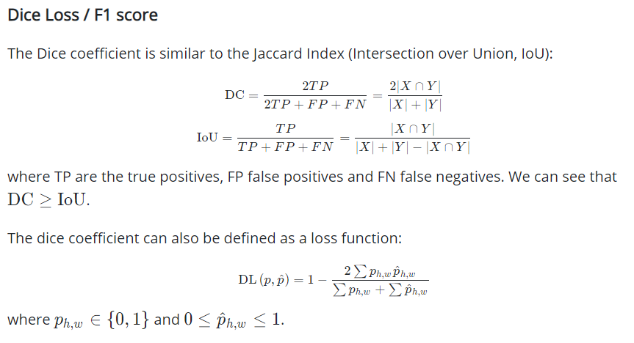
- Balanced Cross Entropy:
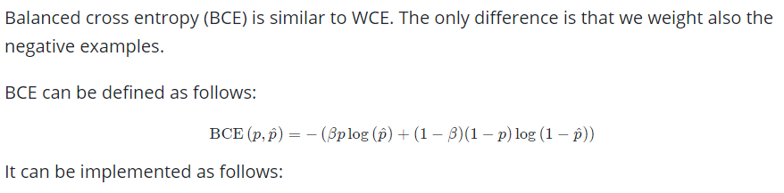
- Weighted Cross Entropy:
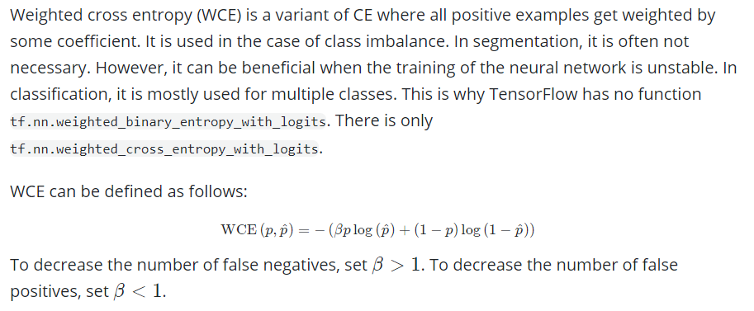
- Intersection Over Union:
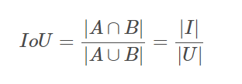
- Tversky Loss:
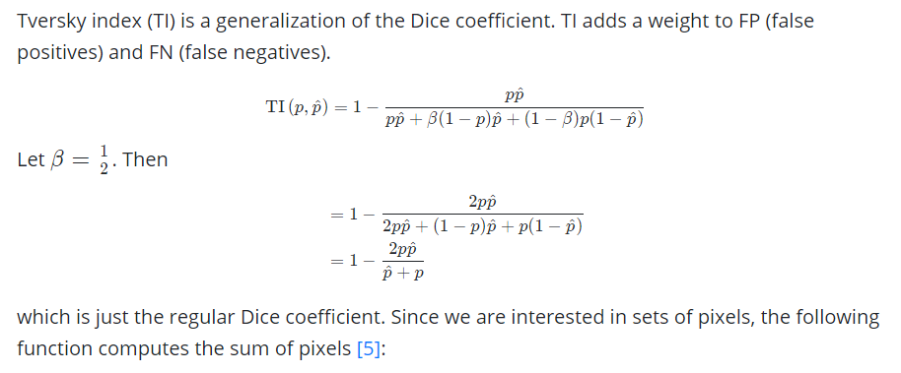
- Lovasz Softmax: is a loss function for multiclass semantic segmentation that incorporates the Softmax operation in the Lovasz extension. The Lovasz extension is a means by which we can achieve direct optimization of the mean intersection-over-union loss in neural networks.
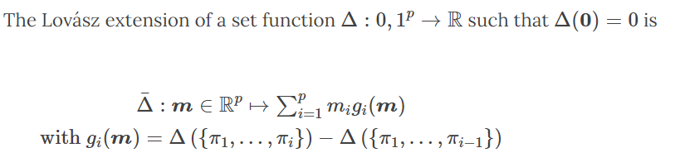
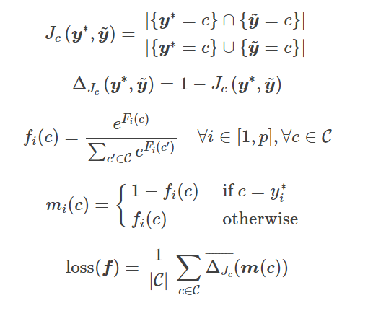
Usage:
- Select a folder for training data, this can either be a single folder with image and label files or two separate folder inputs with the two. If you are using two separate folders you will need to click “Load input folders” this will register your selection of two folder mode. Otherwise for the single folder mode this will be registered along with selecting your folder.
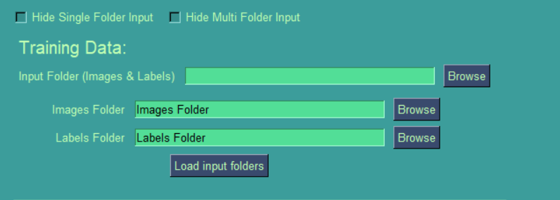
- Select training parameters:
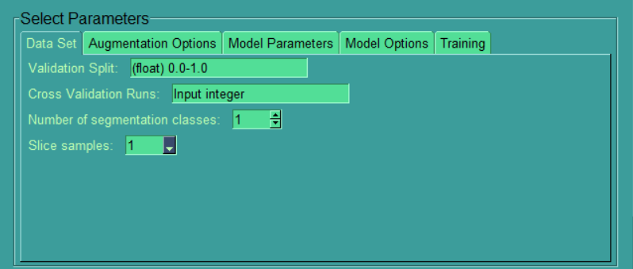

- Save inputs to prepare a MedML.json or create a file name of your choice which will have all your inputs for training ready to train from running train_example.py
You can also load parameter json files to the GUI with load parameters.

4) To train, simply right click the train_example.py in the ide and select run. If errors arise from running this is likely issue with inputted parameters.
5) After successful training, a model.h5 file which you can use for the evaluation step will be created along with best weight files.
Evaluation Window
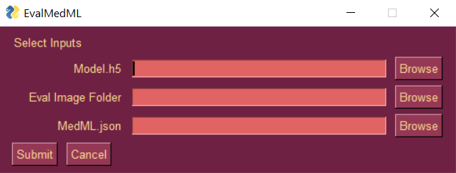
- Here we have the evaluation window where you can select model (.h5), evaluation image folder (e.g. data_eval), and parameters from MedML.json.
- After selecting parameters, you can click submit and this will perform evaluation on the inputs. The result will be a seg_nii file of the segmentation.

